**Story**

|  |  |
| --- | --- |
| Date | 28 June 2025 |
| Team ID | LTVIP2025TMID50924 |
| Project Name | Visualizing Housing Market Trends: An  Analysis of Sale Prices and Features using  Tableau |
| Maximum Marks | 5 Marks |

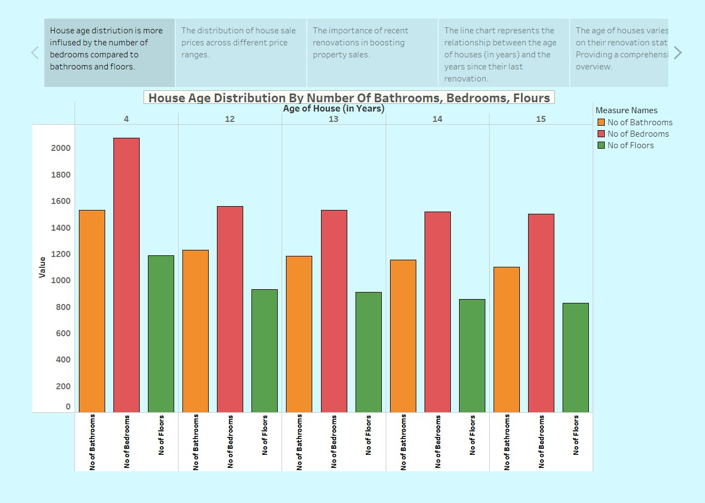

**Observations:**

* **Bedroom Count Dominates** – The number of bedrooms (red bars) has a higher distribution than bathrooms (orange) and floors (green) across all house ages. This suggests that house age distribution is more influenced by bedroom count.
* **Consistent Pattern Across Ages** – The pattern remains relatively stable for different house ages (4, 12, 13, 14, 15 years), indicating no sudden shifts in bedroom, bathroom, or floor counts over time.
* **Potential Influence of Renovations** – Since the chart mentions renovation trends, it's possible that houses with higher bedroom counts have undergone more modifications over time.

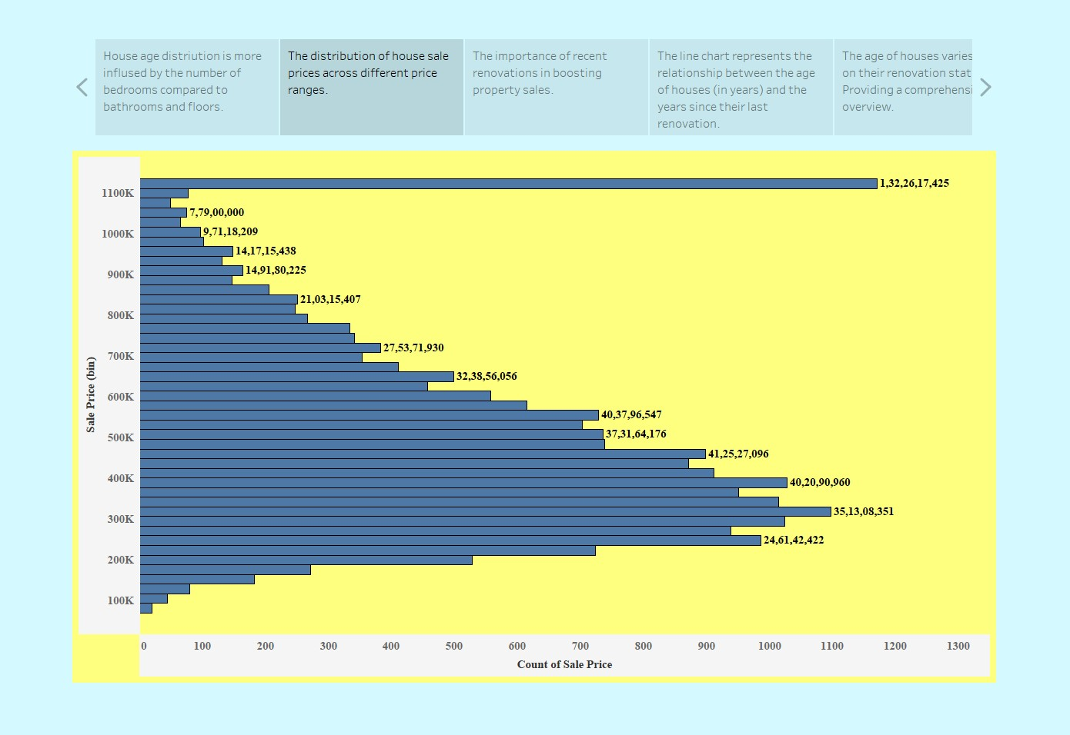

**Observations:**

* **Most Common Sale Prices** – The highest concentration of house sales falls in the range of **300K to 500K**, with **500K being the most frequent sale price range**.
* **Right-Skewed Distribution** – The chart exhibits a right-skewed trend, meaning that **lower-priced homes are more commonly sold**, while high-priced homes are rarer.
* **Extreme High-Value Outlier** – There is a significant outlier at **1.32 million**, which suggests the presence of a few ultra-expensive properties.

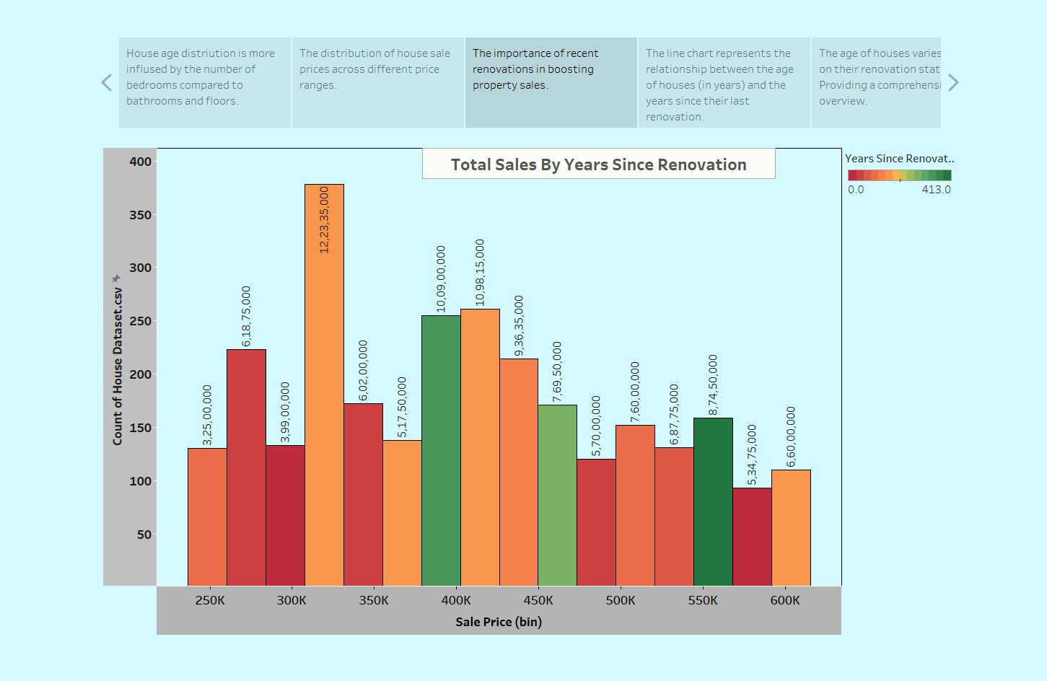

**Observations:**

* **Peak Sales at 300K** – The highest number of sales occurs at the 300K price range, indicating strong demand for affordable houses.
* **Renovated Houses Sell More in Certain Price Ranges** – The 350K and 400K price bins show a high number of sales where houses have been renovated recently (represented by lighter colors).
* **Sales Decline as Prices Increase –** Similar to previous charts, the number of sales gradually decreases beyond 450K, indicating that fewer people purchase expensive homes.

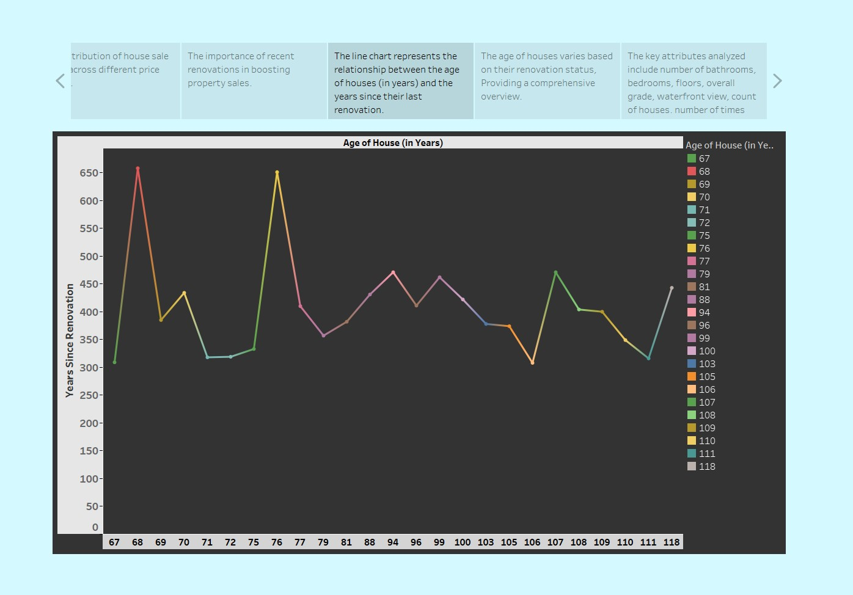

**Observations:**

* **Older Houses Have Longer Time Since Renovation –** Houses that are older tend to have a higher number of years since their last renovation. Some points in the dataset indicate houses that haven't been renovated for over 600 years, which may be a data anomaly or an extreme case.
* **Clusters of Recently Renovated Houses –** Some houses, even with significant ages, show lower years since renovation, meaning they have been maintained or upgraded more recently.
* **Extreme Peaks Indicate Outliers** – The highest spikes may suggest that some very old houses have never been renovated, or the data might have inconsistencies in renovation records.

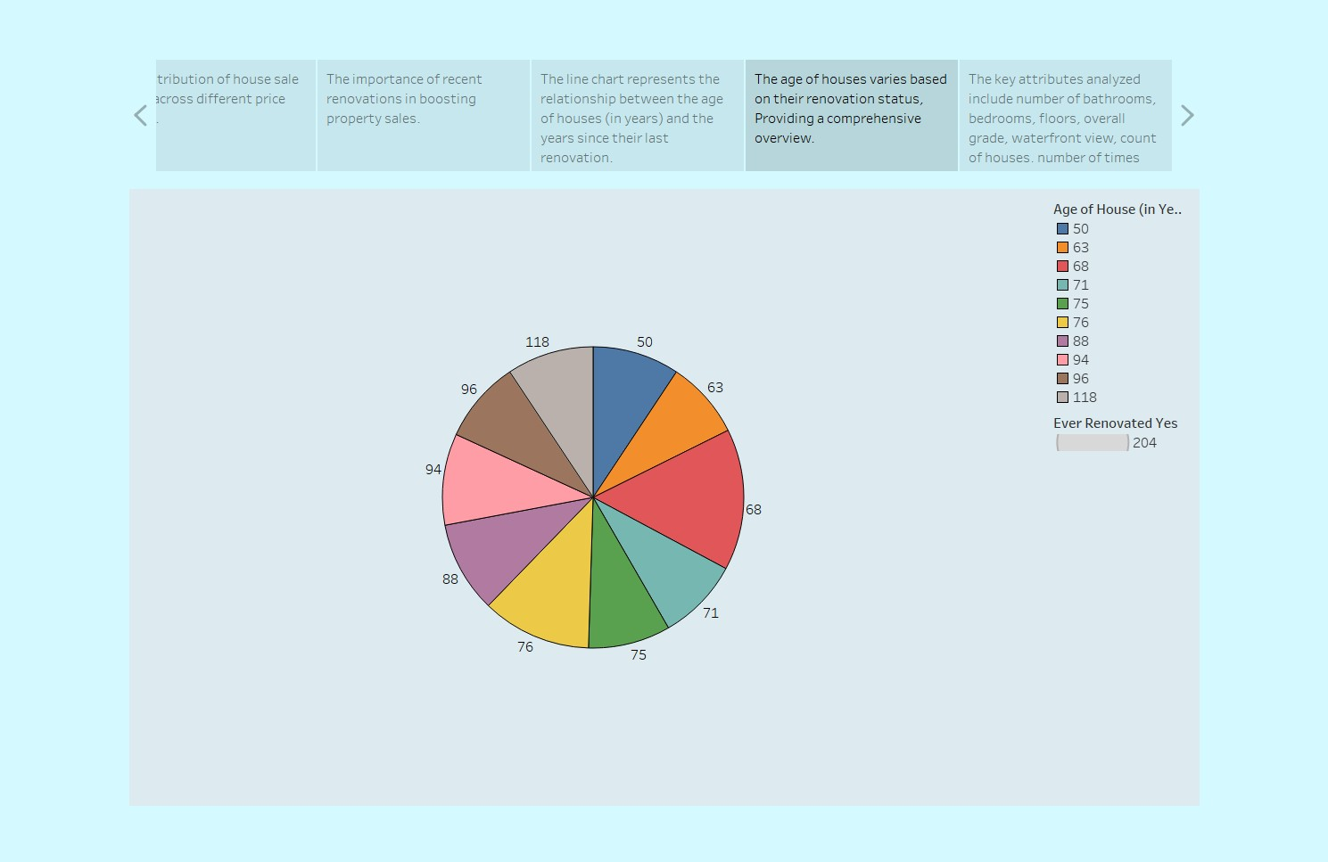

**Observation:**

* **Even Distribution of House Ages** – The chart shows a relatively balanced distribution of houses across different age ranges, with no single age group overwhelmingly dominating.
* **Older Houses (100+ Years) Have a Noticeable Presence** – Houses aged 96 and 118 years occupy significant portions of the pie, suggesting a notable number of older homes in the dataset.
* **Majority of Houses are 50-100 Years Old –** Most houses fall within the 50 to 96-year range, implying that mid-aged homes make up a significant part of the dataset.
* **Renovated House Count is Highlighted –** The 204 houses that have been renovated suggest that a substantial portion of homes in the dataset have undergone upgrades or maintenance at some point.

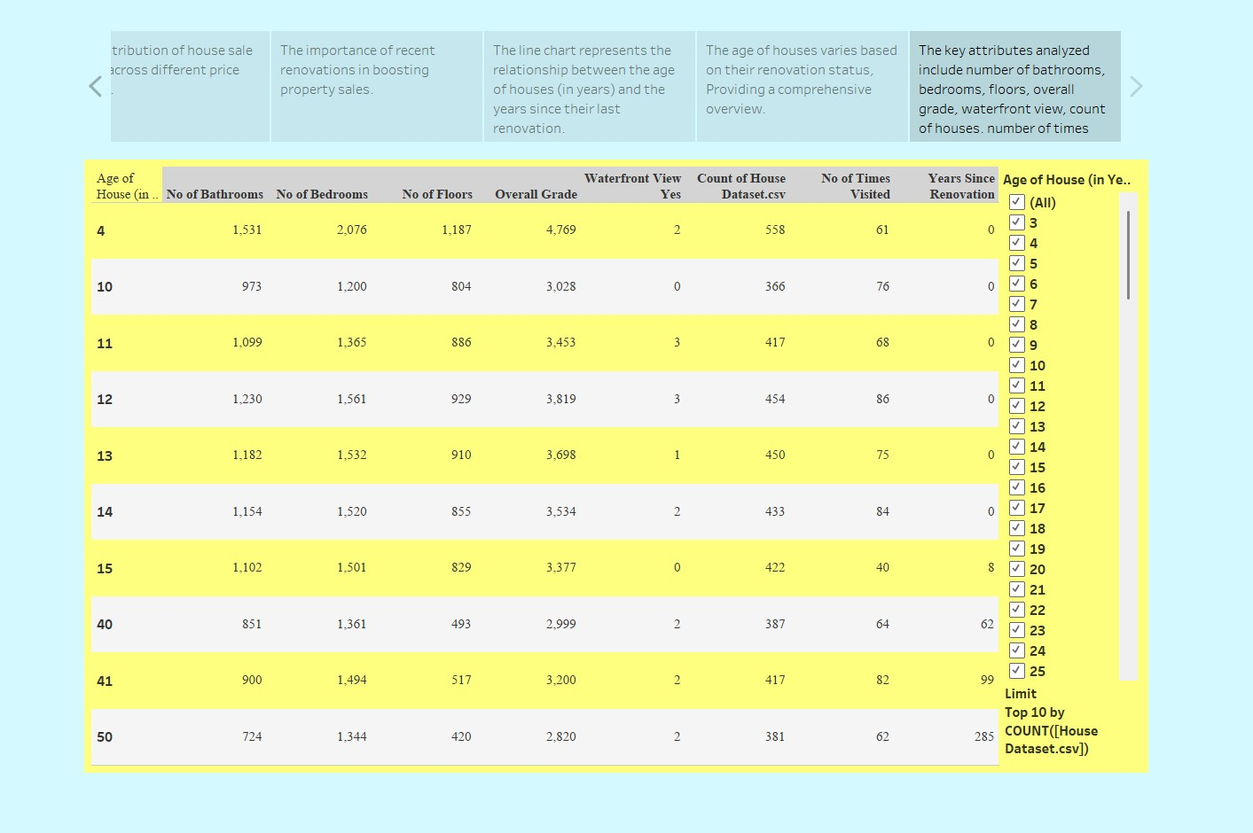

**Observations:**

* **Newer Houses are More Frequent in the Dataset** – The table lists house ages from 4 to 50 years, indicating that newer homes (under 50 years old) are well-represented in the dataset.
* **Overall Grade Decreases with Age** – The overall grade of houses tends to decline as the house age increases (e.g., 4-year-old houses have a grade of 4,769, while 50-yearold houses have 2,820), suggesting that older houses may have lower quality or fewer modern upgrades.
* **Waterfront Views are Limited –** Very few houses have a waterfront view (values range from 0-3 per house age group), suggesting that such properties are rare in the dataset.
* **Count of Houses Decreases with Age –** The number of houses recorded in the dataset reduces as the house age increases. For example, there are 558 houses aged 4 years, but only 381 houses aged 50 years.

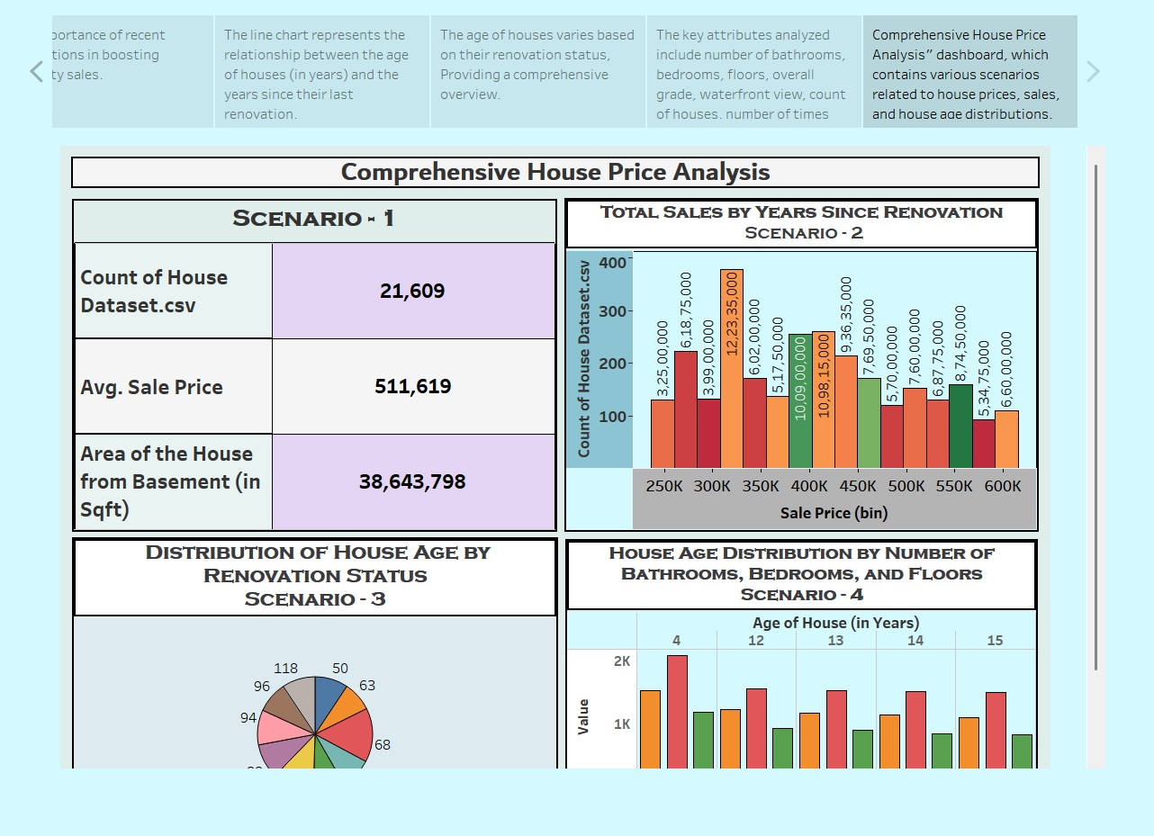

**Observation:**

# Scenario 1 - Dataset Overview

* The dataset contains 21,609 houses.
* The average sale price is $511,619.
* The total house area (including basements) is 38,643,798 sqft. **Scenario 2 - Total Sales by Years Since Renovation**
* The highest number of sales occurs in the $350K price range, indicating this price bracket is the most preferred.
* The $250K and $600K price bins have the least number of sales, suggesting lower demand for both cheaper and premium-priced houses.
* The $400K and $450K price ranges show moderate sales, indicating a balanced market in this segment.

# Scenario 3 - Distribution of House Age by Renovation Status

* The pie chart shows that houses have varying renovation statuses.
* Different age groups of houses exist, with no single age dominating the dataset.
* Some houses are older but still renovated, which could imply that renovations boost house value and marketability.

# Scenario 4 - House Age Distribution by Bathrooms, Bedrooms, and Floors

* Houses around 4 years old have the highest count in terms of the number of bathrooms, bedrooms, and floors.
* The number of bathrooms appears to have a significant impact on house distribution.
* Houses aged 12 to 15 years have a more balanced distribution across different parameters, suggesting these are still competitive in the market.